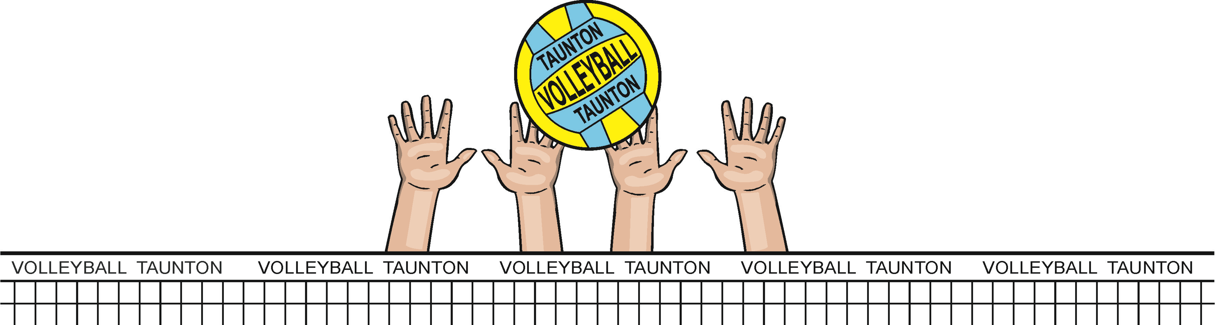


VOLLEYBALL TAUNTON
Club Constitution
- General
  - The name of the Club shall be VOLLEYBALL TAUNTON hereafter known as “the Club”.
  - The Club shall be affiliated to the Volleyball England, and bound by the Rules of the Association.
- Aims & Objectives
  - To promote the game of Volleyball to the highest possible standard.
  - To be open to all who are interested in promoting and playing Volleyball in accordance with the Constitution and Rules.
  - To ensure a duty of care to all members of the Club.
  - To provide all its services and to treat all its members in a way that is fair & equal to everyone.
- Membership
  - Membership should consist of officers and members of the club.
  - All members will be subject to the regulations of the constitution, and by joining the club will de deemed to accept these regulations and codes of conducts that the club has adopted.
- Membership Fees
  - Training and competition fees will be set annually in Annual General Meeting.
  - Persistent non-payment of fees, without extenuating circumstances, shall lead to suspension from attending training nights and matches.
  - All persons representing the Club in League must be paid up Club members.
- Officers of the Club
  - The following Officers shall be elected annually at the Annual General Meeting:
    - Chair
    - Secretary
    - Treasurer
    - Coach
    - Junior Development Officer
    - Child Welfare Officer
    - Volunteer Coordinator
    - Social Events Coordinator
    - Publicity Officer
  - All Officers will retire each year, but will be eligible for reappointment.
- Executive Committee
  - The Club will be managed by an Executive Committee consisting of the Chair, Secretary, Treasurer and Coach. Only these posts will have the right to vote at Executive meetings.
  - Executive meetings shall be convened by the Secretary of the Club and shall occur at least 4 times per year.
  - The Committee shall not vote on any matter unless a quorum of 3 Executive Officers are present.
  - Each Committee member has only one vote, with the exception of the Chair, who has a second casting vote if required.
  - The Committee will be responsible for adopting new policy, codes of conduct and rules that affect the organisation of the Club.
  - The Committee shall not have power to alter the Constitution.
  - The Committee will have powers to co-opt members, and/or to create non-executive posts, to assist in the running of the Club.
  - The Committee will be responsible for disciplinary hearings of members who infringe the club rules/regulations/constitution, and will be responsible for taking any action of suspension or discipline following such hearings.
  - The Committee will have the power to call an Extraordinary General Meeting should the need arise.
- Finance
  - The Club shall have an account at an established financial institution.
  - The Club Treasurer will be responsible for the finances of the Club.
  - Any cheques drawn against Club funds should hold the signatures of the Treasurer plus at least one other Officer.
  - The end of the financial year of the Club will be the end of April.
  - A statement of annual accounts should be presented by the Treasurer at the Annual General Meeting.
- Annual General Meeting
  - This shall be held once a year.
  - Notice of the Annual General Meeting (AGM) will be given by the Club Secretary. Not less than 21 clear days’ notice to be given to all members.
  - Quorum for the AGM will be at least 25% of the active membership.
  - The AGM will receive a report from Officers of the Executive Committee and a statement of the accounts.
  - Elections of officers are to take place at the AGM.
    - The names of Officers/Proposals for the new term of office must be given to the Chair with the names of the Proposer and Seconder prior to the commencement of the AGM.
    - A Proposer or Seconder may only propose and second one candidate for each office.
    - In the event of there being no new nominations for an office, the Chair may take nominations from the floor, duly proposed and seconded.
  - Each Club member has one vote, except the Chair who only has a casting vote when necessary, and may not use absent members’ votes under any circumstances.
  - The AGM has the power to alter the Constitution, provided that two-thirds of those present vote in favour.
  - If there is less than 40% of the club membership present, there can be no vote to alter the Club Constitution.
- Extraordinary General Meeting
  - The Management Committee has the right to call Extraordinary General Meetings (EGMs) outside the AGM. Procedures for EGMs will be the same as for the AGM
  - Any member of the Club has the power to call an EGM, should the need arise provided that:
  - A written proposal is submitted to the Secretary or Chair.
  - The Proposer has a Seconder.
  - A petition carrying the signatures of at least 10% of the active membership shall accompany the written proposal.
- Discipline & Appeals
  - All complaints regarding the behaviour of members should be submitted in writing to the Secretary.
  - The Executive Committee will meet to hear complaints within 14 days of a complaint being lodged. The committee has the power to take appropriate disciplinary action including the termination of membership.
  - The outcome of a disciplinary hearing should be notified in writing to the person who lodged the complaint and the member against whom the complaint was made within 14 days of the hearing.
  - There will be the right of appeal to the Executive Committee following disciplinary action being announced. The committee should consider the appeal within 14 days of the Secretary receiving the appeal.
- Dissolution
  - A resolution to dissolve the club can only be passed at an AGM or EGM through a majority vote of the membership.
  - In the event of dissolution of the Club, all its assets will be frozen. If the club is no longer a going concern after 2 years, its assets will be sold off and all the money obtained will be transferred to the Volleyball England.
- Declaration

Volleyball Taunton hereby adopts and accepts this constitution as a current operating guide regulating the actions of members.

Chair Secretary Treasurer

Signed

Name

Date

